Static Timing Analysis

Lab2: Understanding Delay Calculation

Objective
To study:
- Generating Endpoint slack diagram
- Generating delay calculation reports
- Understand delay calculation principle.

Laboratory task

- Load Gate Level design into PrimeTime
- Generate Histogram view of Endpoint slack
- Perform manual delay calculation.
Supporting information for doing laboratory work
Laboratory work is performed on a gate level design generated by compiling given RTL code (Listing 2.1) using Design Compiler (Fig 2.1). Sample SDC file is also provided as reference (Listing 2.2).
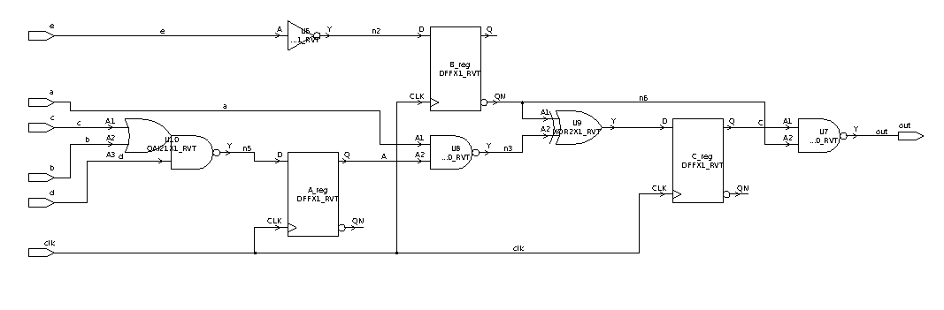
Fig. 2.1. A Sample Circuit

Listing 2.1 Example Circuit RTL (circuit.v)
module circuit (a,b,c,d,e,clk,out);
input a;
input b;
input c;
input d;
input e;
input clk;
output out;
reg A;
reg B;
reg C;

assign f= ~(d&(c|b));
assign g=~e;
assign h= ~B|~(a&A);

assign out= ~( ~(B) & C);

always @ (posedge clk)
begin
A= f;
B= g;
C= h;
end

endmodule

Listing 2.2. Example Circuit Constraints (circuit.sdc)
set_load -pin_load 0.04 [get_ports {out}]

create_clock [get_ports clk] -period 10 -waveform {0 5}
set_clock_uncertainty 0.4 [get_clocks clk]
set_propagated_clock [get_clocks clk]
set_clock_transition -rise 0.8 [get_clocks clk]
set_clock_transition -fall 0.8 [get_clocks clk]
set_wire_load_model -name 8000
set_input_delay -clock clk 5 [get_ports a]
set_input_delay -clock clk 5 [get_ports b]
set_input_delay -clock clk 5 [get_ports c]
set_input_delay -clock clk 5 [get_ports d]
set_input_delay -clock clk 5 [get_ports e]
set_output_delay -clock clk 8 [get_ports {out}]

1. Loading Gate Level design into PrimeTime
First load design along with constraints into PrimeTime. Below is a sample script to it.

set link_path ../library/saed32rvt_tt1p05v25c.db
read_verilog ../results/circuit_gate.v
read_sdc ../source/circuit.sdc

2. Generating Histogram view of Endpoint slack
Using Timing->Histogram-> Endpoint slack generates endpoint slack diagram (Fig. 2) showing number of endpoints with different values of slack. By selecting endpoint in the diagram, Path Inspector window can be opened (Fig. 3) which represents timing report’s detailed information.

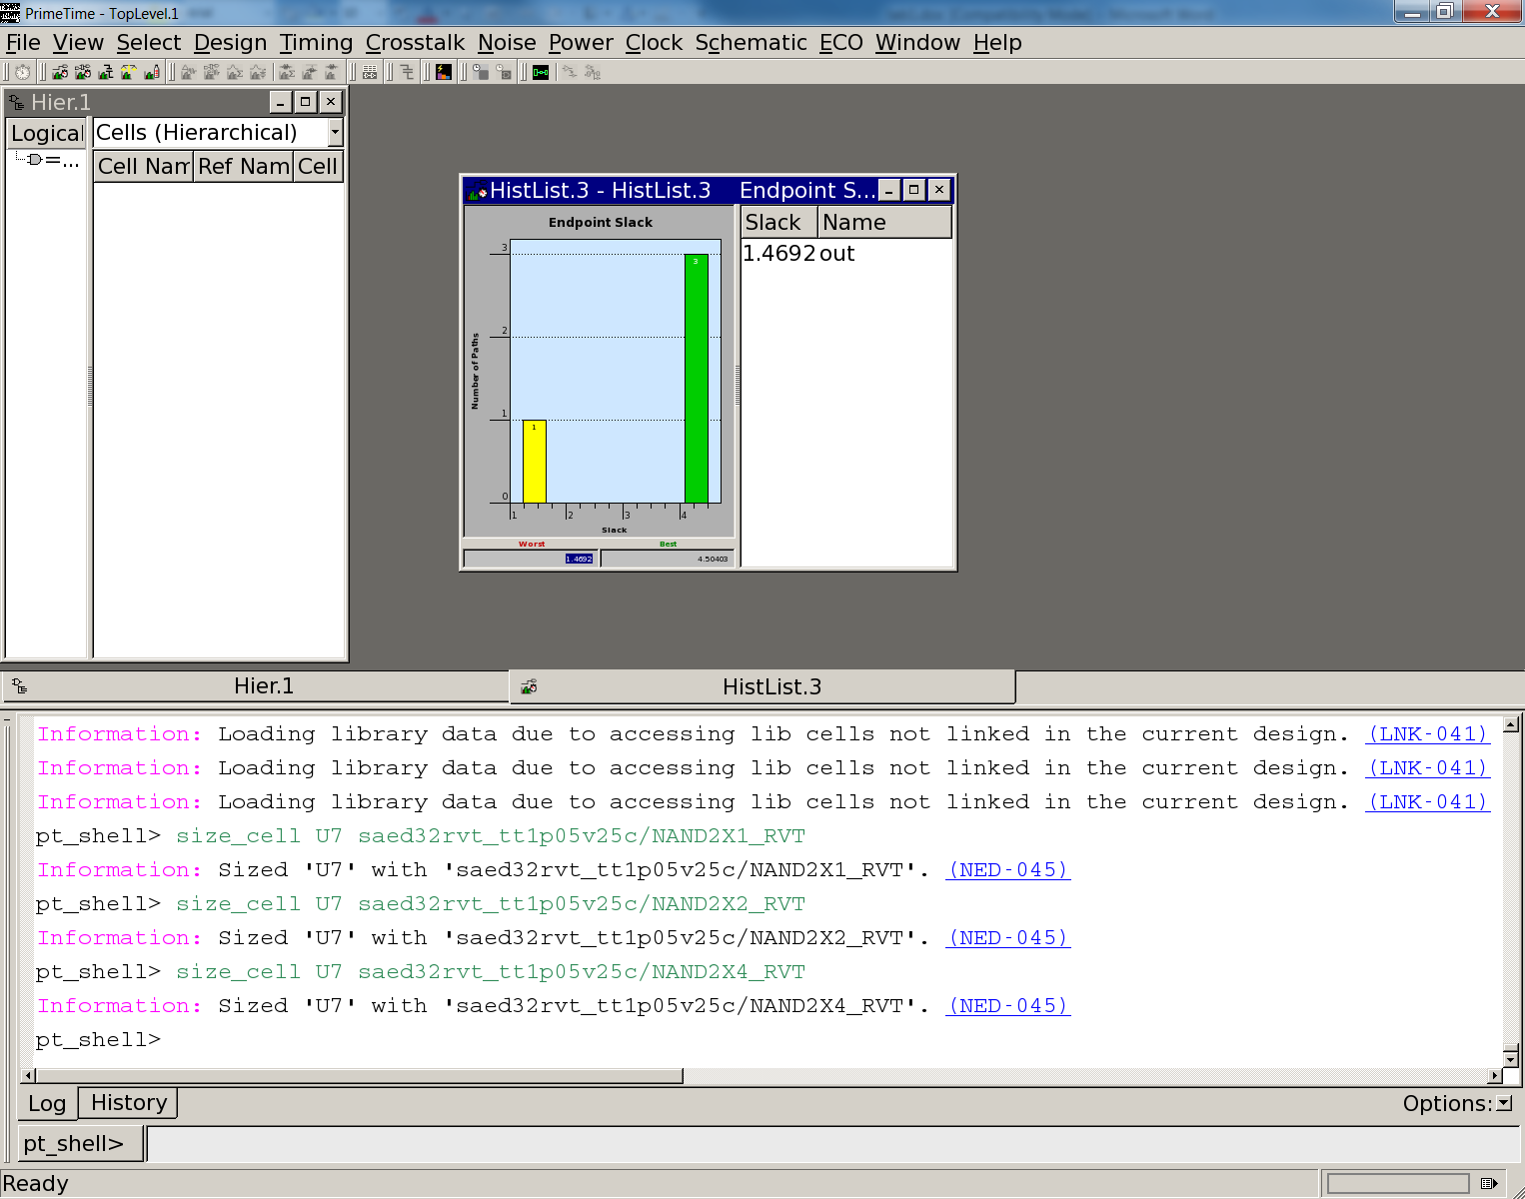
Fig. 2.2. Histogram view of Endpoint slack

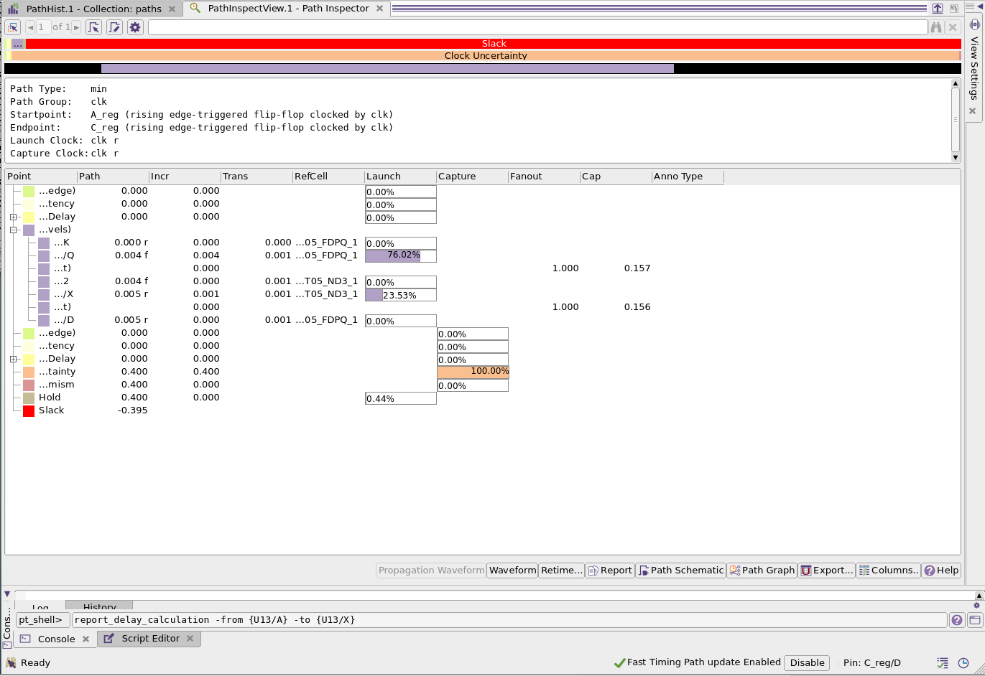
Fig. 2.3. Path Inspector window

3. Delay Calculation principle
Both timing reports and Path inspector contain delay values for cells in increments of path delay. These delay values are calculated based on lookup tables of delay provided for each cell. Lookup tables contain cell delay values for several combination of input transition and output capacitance values. To see actual calculation process for specific cell, the following command can be used:
report_delay_calculation -from {pin} -to {pin}

For example:
report_delay_calculation -from {U13/A} -to {U13/X}command provides result similar to the one below:

****************************************
Report : delay_calculation
Design : circuit
Version: S-2021.06-SP4
Date : Tue Dec 13 10:08:54 2022
****************************************

From pin: U13/A
To pin: U13/X
Main Library Units: 1ns 0.001pF 1000kOhm

Library: 'saed05nlplogl06hdl060f_tt0p75v25c'
Library Units: 1ns 0.001pF 1000kOhm
Library Cell: 'SAEDSVT05_INV_1'
arc sense: negative_unate
arc type: cell
Units: 1ns 0.001pF 1000kOhm

Rise Delay

cell delay = 0.000857806
Table is indexed by
(X) input_pin_transition = 0
(Y) output_net_total_cap = 0.1558
Relevant portion of lookup table:
(X) 0.0030 (X) 0.0053
(Y) 0.1500 (Z) 0.0016 (Z) 0.0022
(Y) 1.6050 (Z) 0.0041 (Z) 0.0055

Z = A + B*X + C*Y + D*X*Y
A = 0.0007 B = 0.2255
C = 0.0010 D = 0.2302

Z = 0.000857806
scaling result for operating conditions
multiplying by 1 gives 0.000857806

In this report delay calculation for specific cell input to output delay is shown. Here for cell 'SAEDSVT05_INV_1' delay calculation is reported. Input transition at cell is 0 and output capacitance is 0.15. Thus there is an excerpt from the lookup table shown for four closest delay values.

(X) input_pin_transition = 0
(Y) output_net_total_cap = 0.1558
Relevant portion of lookup table:
(X) 0.0030 (X) 0.0053
(Y) 0.1500 (Z) 0.0008 (Z) 0.0011
(Y) 1.6050 (Z) 0.0025 (Z) 0.0028

Based on these four values and knowing that delay function (Z) dependence on transition (X) and output load (Y) can be expressed as Z = A + B*X + C*Y + D*X*Y(this is a result of approximation) delay value for known X (0) and Y(0.15) can be calculated. To calculate A, B, C, D factors, there is this system of equations:

$$\left\{\begin{aligned}0.0008 = A+B*0.0030+C*0.1500+D*0.0030*0.1500 \\ \begin{aligned}0.0025 = A+B*0.0030+C*1.6050+D*0.0030*1.6050 \\ 0.0011 = A+B*0.0053+C*0.1500+D*0.0053*0.1500 \\ 0.0028 = A+B*0.0053+C*1.6050+D*0.0053*1.6050\end{aligned}\end{aligned}\right.$$

Subtracting equations in the following order (2-1) and (4-3) will result in:
$$\left\{\begin{aligned}0.0017 = C*1.4550+D*0.0030*1.4550 \\ 0.0017 = C*1.4550+D*0.0053*1.4550\end{aligned}\right.$$
Subtract first equation from the second one to find D:

$$0 = D*0.0023*1.4550 => D = 0$$

Replace the D value in the first equation to find the C factor:

$$C = 0.0017/1.4550 = 0.0011$$

To find A and B, replace the values of C and D into the (1) and (3) equations:
$$0.000635 = A+B*0.0030$$
$$0.000935 = A+B*0.0053$$

$$B*0.0023 = 0.0003→ B = 0.1304$$
$$A = 0.000635-B*0.0030 → A = 0.00024$$

And finally for delay, there is:
$$Z = 0.00024 + 0.1304*(X) + 0.0011*(Y) + 0*(X)*(Y) = 0.00024 + 0.1304 * 0 + 0.0011 * 0.1558 +$$
$$+ 0* 0 * 0.1558 = 0.000411$$

Report
The report should have:
- Design Compiler and PrimeTime scripts
- The gate level circuit
- Histogram view of Endpoint slack
- Delay calculation steps for one of the paths
- Brief summary.

